Introduction

Introduction

Survey data is abundant but insights are rare. Organizations collect thousands of responses annually, yet struggle to extract meaningful intelligence that drives decision-making. This report presents a comprehensive analysis of the GradSingapore employer survey, demonstrating how machine learning, statistical analysis, and large language models can systematically improve survey design, understand respondent behavior, and uncover strategic insights for HR and employer branding teams.

Problem Statement
Creating a prototype that assists companies in analysing survey responses, improving survey design, and generating actionable insights for internal uses.
The solution should allow users to:
- Identify patterns, correlations, or redundancies in survey questions that suggest opportunities for improvement
- Understand factors associated with partial or incomplete survey responses
- Discover meaningful demographic or behavioural segments among respondents
- Extract insights from the applicant’s perspective on what drives employer attractiveness
- Automatically synthesise and present insights in a clear and interpretable format, potentially using LLMs

Analysis
The team performed analysis on the GradSingapore employer survey dataset, applying advanced analytical techniques to a real-world collection of 2,614 responses from graduate students across Singapore universities, uncovering key insights that target the problem statement.

Dataset Overview

Data Summary

The GradSingapore employer survey captured responses from graduate students evaluating employer attractiveness and career preferences. Key characteristics of dataset:
- Total Responses: 2,614
- Survey Variables: 23 variable
- Respondent Base: Graduate students from 25 distinct institutes, including NUS, NTU, SMU, and private universities such as James Cook University, PSB Academy, and Kaplan Singapore

Response Quality
To be considered as Complete the following 3 questions must be answered

- Which of these statements best describes your current perception of the organisation as an employer
- On a scale from 1 to 10 (1 – Low, 10 – High), how would you rate the attractiveness of the organisation as an employer?
- Which of these factors would most motivate you to apply for a position at the organisation?
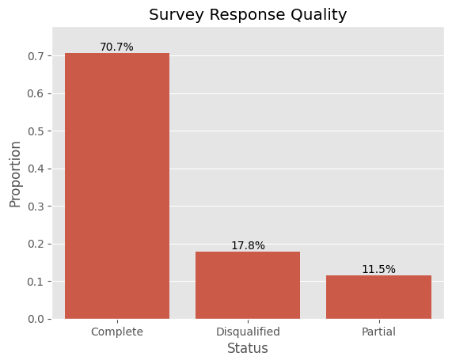

Key Demographics

- Institution Distribution: 66.1% National University of Singapore (NUS), 21.3% Nanyang Technological University (NTU), 2.8% Singapore Management University (SMU), 9.8% Other
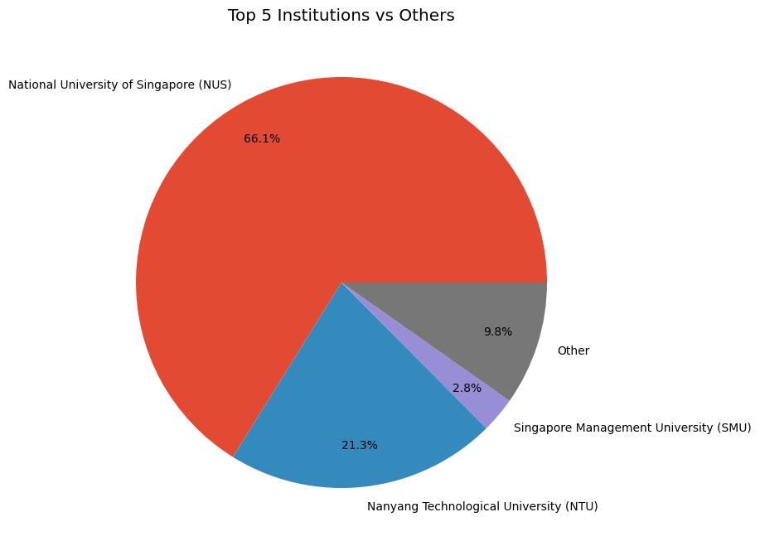

- Gender: 58.9% Female, 38.1% Male, 3% Other/Prefer not to say
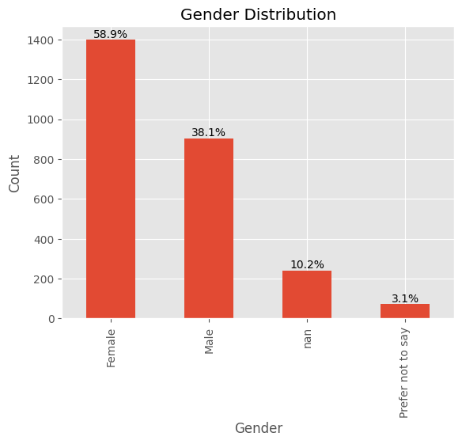
- Nationality: 84.8% Singaporean/Permanent Resident
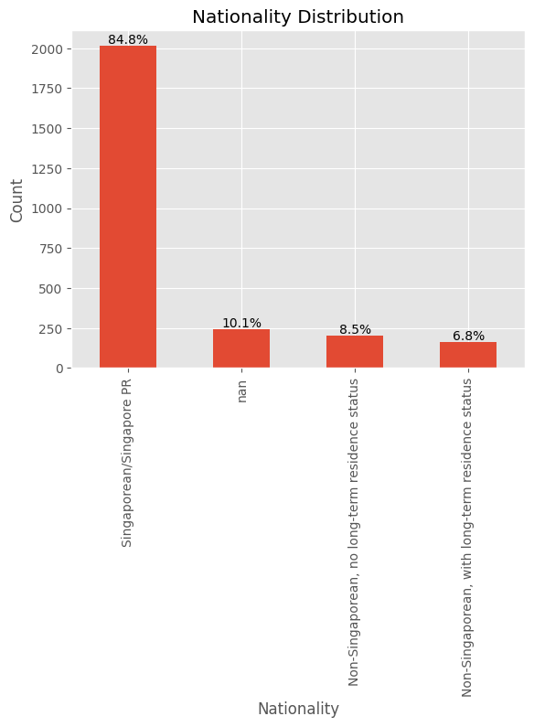
- Subject Distribution: Participants majors have been mapped into categories as shown below
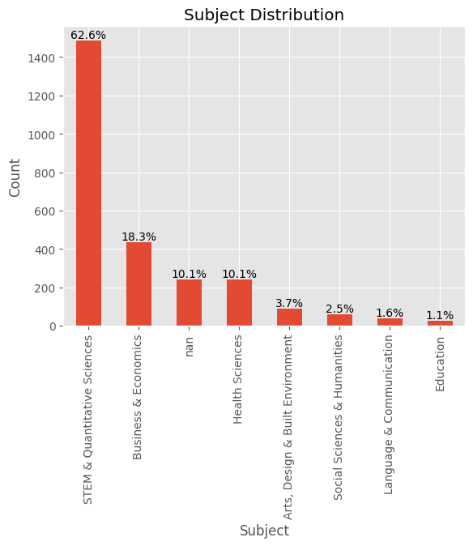

- Survey Variables Distribution: Metadata (11 columns), Demographics (10 columns), Preferences(5 columns), Ratings(3 columns), Open-ended(3 columns)

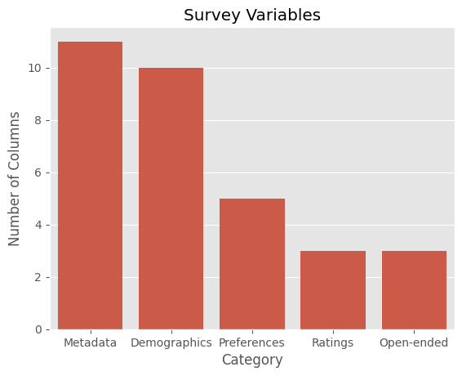

Data Quality Notes
- Presence of NULL values in majority of the survey variables
- Geographic Anomaly: 165 students from Singapore institutions with non-Singapore IPs (likely VPN usage, study abroad programs, or students currently overseas)

Methodology

Methodology
Our analysis employs four complementary analytical approaches to extract comprehensive insights from survey data, insights can be found under the Insights tab.

1. Correlation Analysis
We mapped the underlying relationships between all significant variables in the dataset through:

- Bivariate Correlation: Conducted a statistical assessment, Pearson’s correlation, to measure the strength and direction of linear relationship between the various columns
- Heatmap Visualisation: Generated a correlation matrix to easily identify highly interdependent variables.

2. Feature Importance Analysis
We identified the primary drivers for employer Attractiveness in the dataset through:

- XGBoost Modeling: Utilized a gradient-boosting decision tree algorithm to analyze the predictive power of various attributes such as perception, motivation factors and year of study.
- Feature Priority Ranking: Extracted and ranked feature importance scores to isolate and identify the most relevant columns that significantly influence the model’s ability to successfully predict the correct level of attractiveness.

3. Cluster Analysis
We identified 3 distinct clusters in the dataset through

- K-means Clustering: Applied unsupervised learning to group respondents based on institution, academic subject, year of study, and stated motivations.
- Segment Profiling: Created detailed profiles for each cluster based on their characteristics and survey behavior.

This segmentation aims to identify meaningful demographic and behavioural segments among respondents as well as what drives employer attractiveness. Specifically, the segmentation results are used to compare employer attractiveness score distributions across clusters, examine differences in the relative importance of key motivation factors, and analyse variation in information needs using cluster-level percentage measures. These comparisons enable a structured assessment of how perceptions, motivations, and information preferences differ across applicant segments.

4. Survey Attrition Analysis and Data Segmentation
Survey attrition analysis involves partitioning the primary dataset into three discrete cohorts based on the Status attribute. This allows for a comparative study of respondent behavior across the three different completion states: Partial, Disqualified, Complete. From here, we plot the graphs of completed responses per question for each of the three completion states, and we can identify questions that had low responses and link them to each state of completion.
For data segmentation, we used three main metrics:

- Z-Score normalized duration: Duration is first calculated through the difference between time started and date submitted. Then, to ensure good comparison of average completion times, a Z-Score Normalization function is applied to eliminate noise caused by extreme outliers, as some respondents' time durations were so long that they would statistically mask the behavior of the average user. Our threshold is defined as an upper bound at 3 standard deviations from the mean, any data point exceeding this threshold is excluded from the final average.

- User Agent: Analyzing the "Mobile" vs. "Desktop" split to determine if device type influenced the completion status.

- Qualification: Aggregating the "Qualification" column to identify if specific respondent backgrounds correlate with higher drop-off or completion rates.

Results

Results

Correlation Analysis
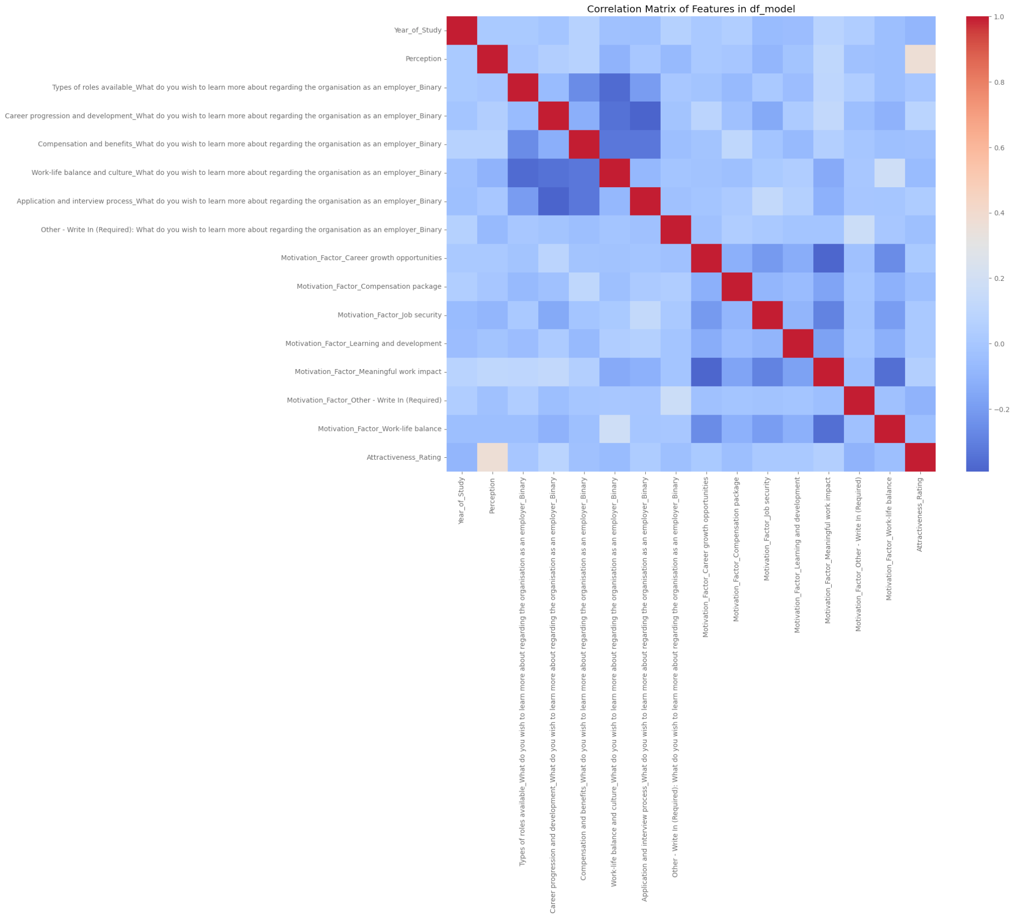

Feature Importance Analysis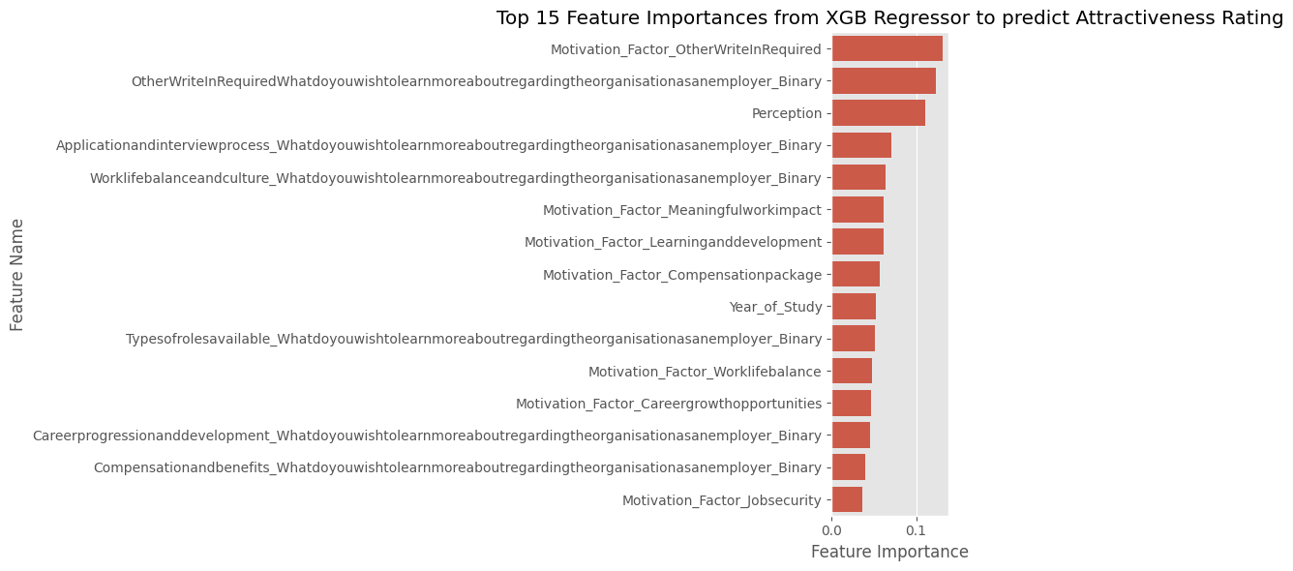

Cluster Analysis

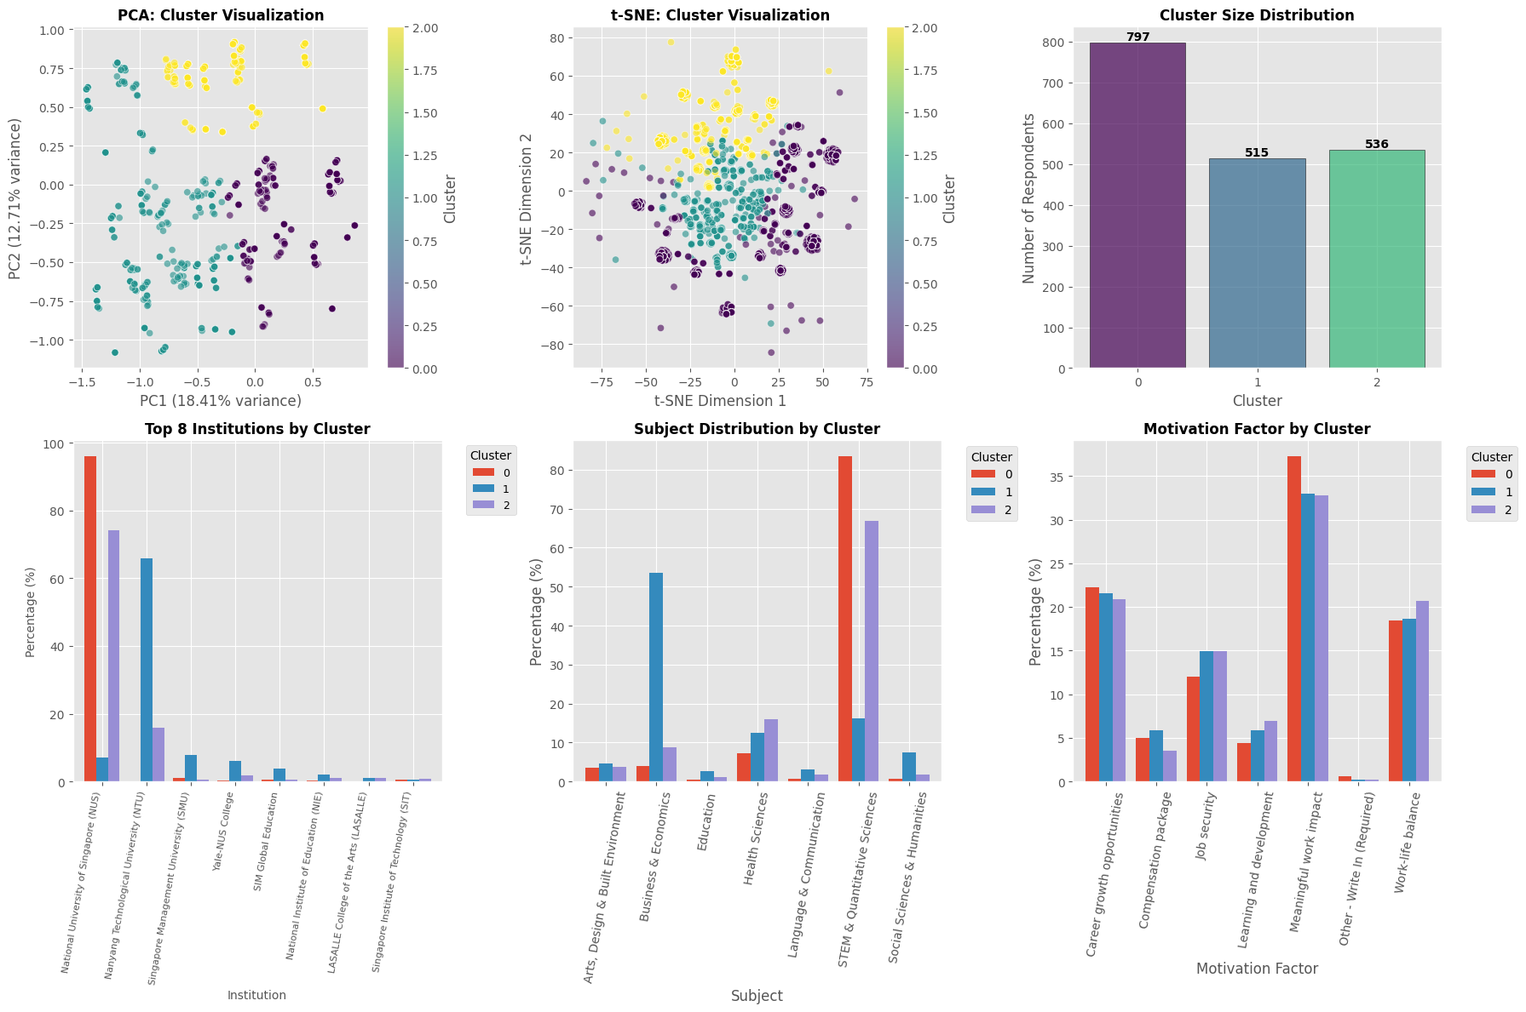

Dominant Profile
Cluster | Institution | Subject | Year | Motivation
Cluster 0 | National University of Singapore (NUS) | STEM & Quantitative Sciences | Year 2 | Meaningful work impact
Cluster 1 | Nanyang Technological University (NTU) | Business & Economics | Year 2 | Meaningful work impact
Cluster 2 | National University of Singapore (NUS) | STEM & Quantitative Sciences | Year 1 | Meaningful work impact

Our clustering analysis identified three distinct respondent clusters with different needs and behaviors:
Cluster 0
- Profile: Y2-Y4 Students, with a majority from NUS with STEM and Quantitative Sciences
- Behaviour Characteristics: Most career orientated Meaningful work impact(37.3%), Moderate work balance (18.4%), slightly lower than year 1 students (cluster 2), Past the exploratory stage with Learning and development at (4.4%), Lower compensation focus than compared to year 1 students with Compensation package at (5.0%)
- Psychographics Profile: Missen-driven professionals aimed in making impact rather than maximise financial returns
Cluster 1
- Profile 1: Y1-Y4 Students with high concentration of Y2 students. Dominated by NTU students with notable institutional diversity. Only cluster where Business and Economics students are the majority
- Behaviour Characteristics: Pragmatic career orientation with highest job security focus among the clusters. Equal emphasis on "Learning and development" and "Compensation"
- Psychographics Profile: Business minded pragmatists seeking stable career paths
Cluster 2
- Profile: Y1 students, primary NUS students. STEM and Quantitative Sciences focused but more diverse compared to Cluster 0
- Behaviour Characteristics: Still in exploratory mode, highest worklife balance and less financially driven among all clusters
- Psychographics Profile: Idealistic newcomers prioritizing balance and growth, more of wellness-conscious generation entering university
The data in the clusters revealed that
1. Year of Study drives Behavioral Differences

- Work Life Balance: Work-life balance: Freshmen prioritize it MORE (20.7%) vs seniors (18.4-18.6%), younger students are more wellness conscious.

- Learning and development: Freshmen value it MORE (6.9%) vs seniors (4.4-5.8%), Curiosity decreases as students progress, they become more goal-directed.

- Compensation: Freshmen care LESS about salary (3.5%) vs seniors (5.0-5.8%), students worry about their expenses and cost of living as they go up the years.

2. Meaningful Work Impact

- ALL three segments prioritize meaningful work (33-37%) as #1 motivation, contributing to society and doing something meaningful resonates with the student generation.

3. Institutional Diversity Patterns
- In terms of Institutions, Cluster 0 is most homogeneous with Cluster 1 being most diverse in terms of Institutions. Cluster 0 is STEM dominated while Cluster 1 is Business & Economics dominated, business education draws from a broader institutional base while STEM concentrates at elite universities.

Attractiveness Score Range by Cluster
The box plot illustrates the distribution of employer attractiveness ratings across the three clusters. Cluster 1 shows the highest median attractiveness score (around 7), indicating that respondents in this group generally perceive employers more positively. However, this cluster also exhibits a relatively wide interquartile range, suggesting greater variation in individual perceptions.
Clusters 0 and 2 have slightly lower median scores (around 6) and more compact distributions, implying more consistent but moderately positive evaluations. The presence of lower-end outliers in all clusters indicates that negative perceptions exist across groups, although they are not dominant. Overall, the results suggest meaningful heterogeneity in how different applicant segments perceive employer attractiveness, reinforcing the importance of cluster-specific employer branding strategies.
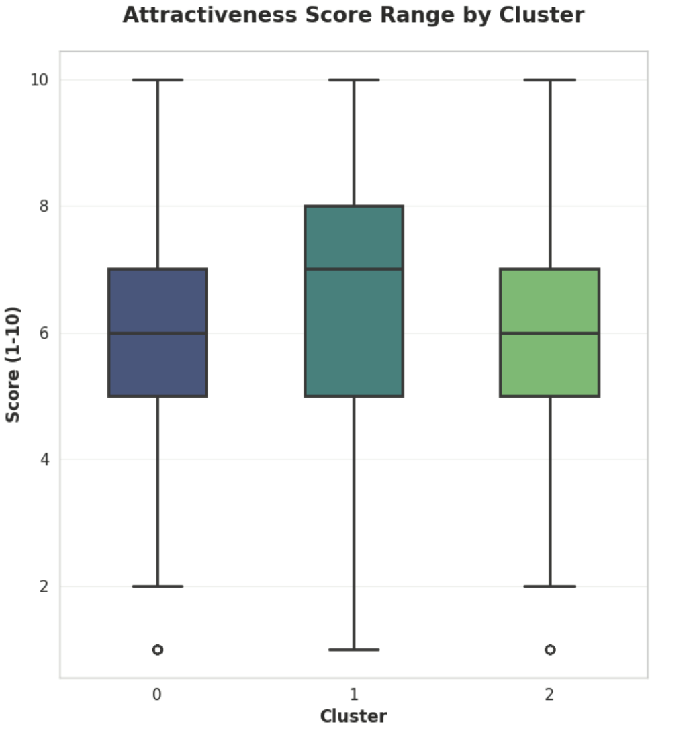

Average Attractiveness Score by Motivation Factor (Top 5)
This bar chart highlights the top five motivation factors ranked by their average attractiveness scores. Meaningful work impact and learning and development are the highest-rated factors, both with an average score of 6.4, indicating that intrinsic and growth-oriented motivations play a critical role in shaping employer attractiveness.
Career growth opportunities and job security follow closely, each with an average score of 6.3, suggesting that long-term career considerations remain highly relevant to applicants. Work-life balance, while still important, ranks slightly lower with an average score of 6.1. Overall, the relatively narrow score range (6.1–6.4) implies that these factors are all important, but opportunities for meaningful work and skill development provide a slight competitive edge in enhancing employer attractiveness.
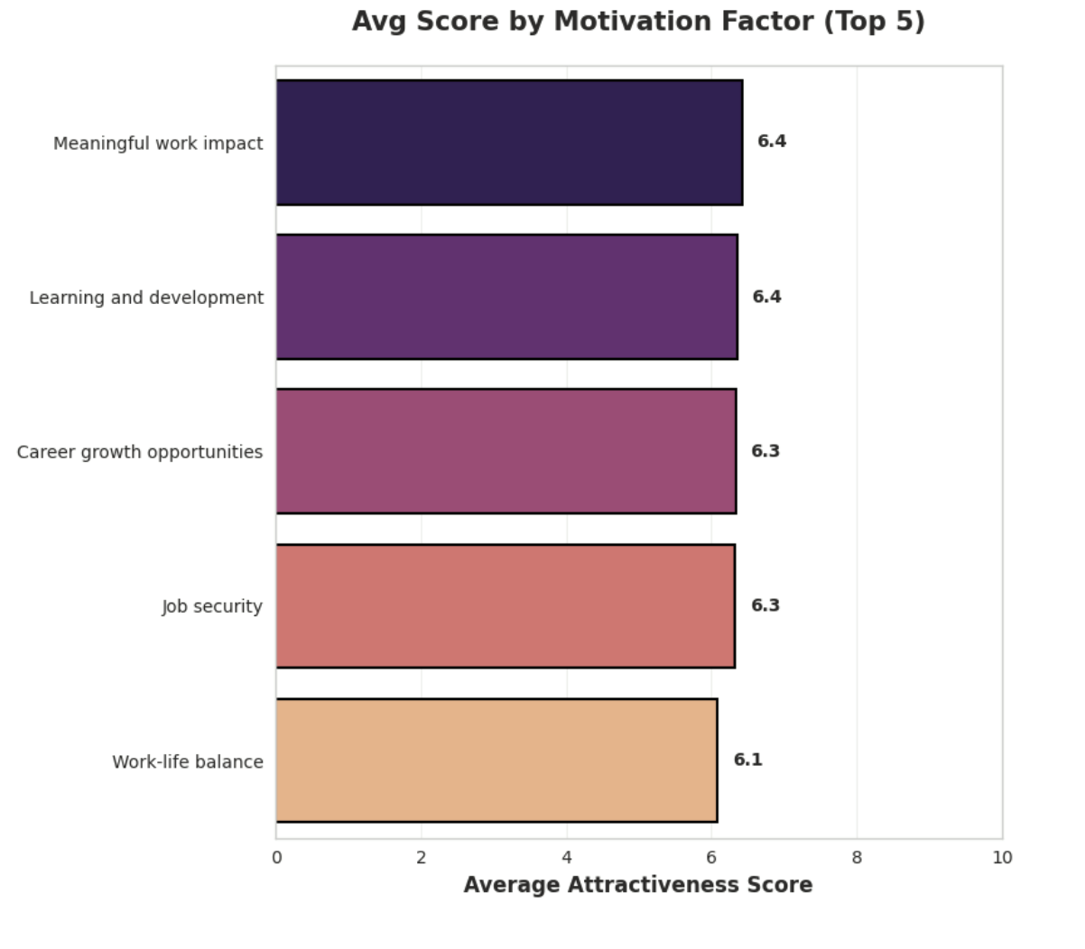

Information Needs Percentage by Cluster
The heatmap reveals clear differences in information needs across clusters. Across all clusters, roles available and career progression are the most frequently requested information categories, with percentages consistently above 70%. For example, Cluster 2 shows the highest demand for information on roles (78.5%) and career development (75.9%).
Interest in compensation and benefits is also substantial, ranging from 59.9% to 68.0%, while work-life balance and culture attracts moderate attention (approximately 54%–57% across clusters). In contrast, application and interview process information is less frequently requested (around 28%–31%), and other information is negligible across all clusters (below 1%).
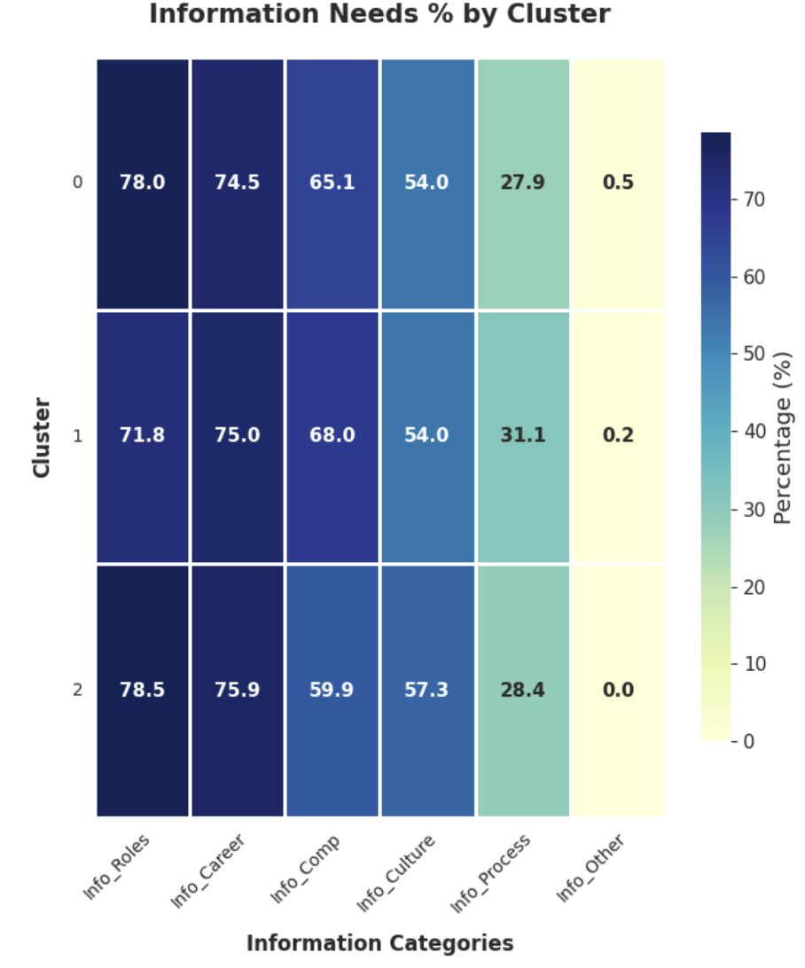

Survey Attrition Analysis and Data Segmentation
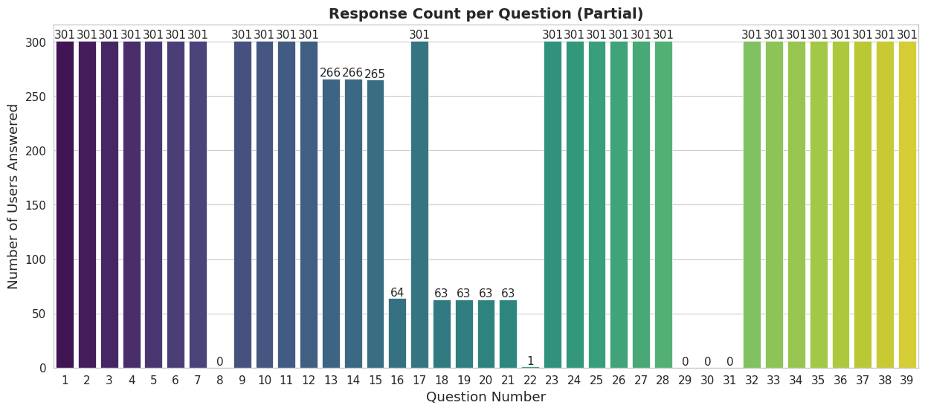
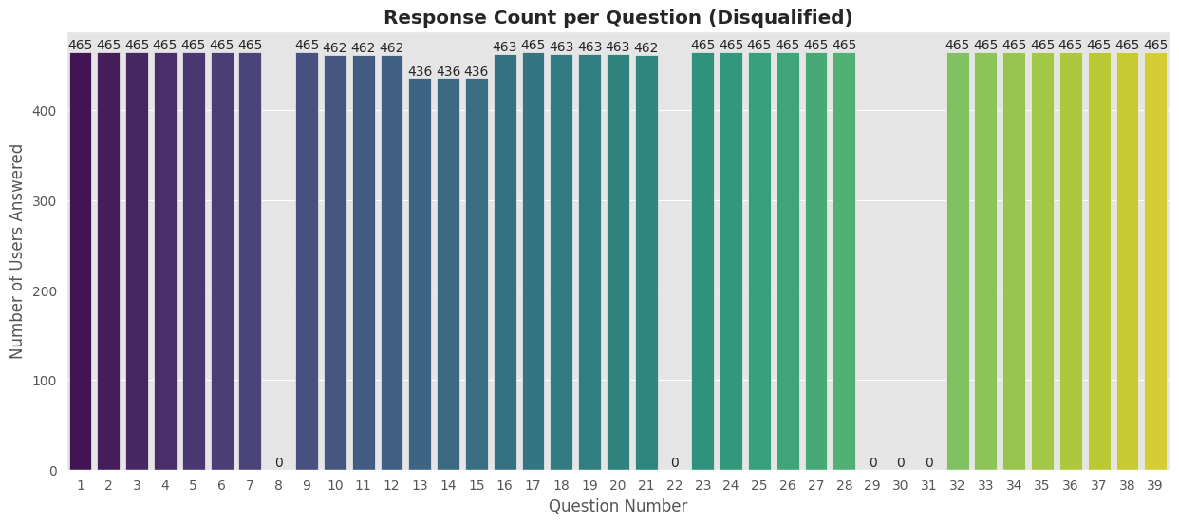
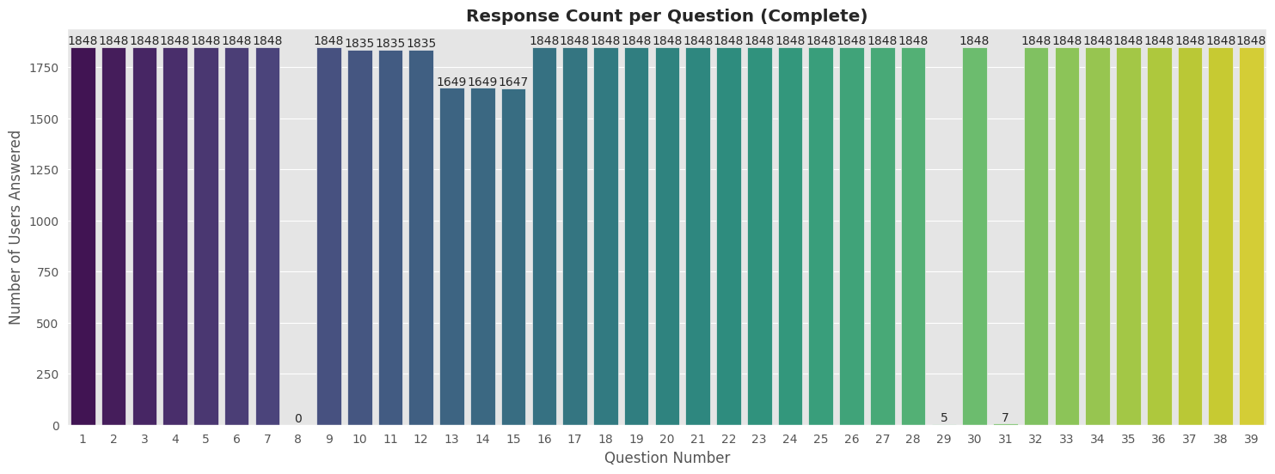
Legend for question number:
[1: Response ID]
[2: Time Started]
[3: Date Submitted]
[4: Status]
[5: Language]
[6: SessionID]
[7: User Agent]
[8: Tags]
[9: IP Address]
[10: Longitude]
[11: Latitude]
[12: Country]
[13: City]
[14: State/Region]
[15: Postal]
[16: Institution]
[17: Year_of_Study]
[18: Qualification]
[19: Subject]
[20: Nationality]
[21: Gender]
[22: Perception]
[23: Types of roles available_What do you wish to learn more about regarding the organisation as an employer_Binary]
[24: Career progression and development_What do you wish to learn more about regarding the organisation as an employer_Binary]
[25: Compensation and benefits_What do you wish to learn more about regarding the organisation as an employer_Binary]
[26: Work-life balance and culture_What do you wish to learn more about regarding the organisation as an employer_Binary]
[27: Application and interview process_What do you wish to learn more about regarding the organisation as an employer_Binary]
[28: Other - Write In (Required): What do you wish to learn more about regarding the organisation as an employer_Binary]
[29: Other - Write In (Required):What do you wish to learn more about regarding the organisation as an employer?]
[30: Attractiveness_Rating]
[31: Other - Write In (Required):Which of these factors would most motivate you to apply for a position at the organisation?]
[32: Motivation_Factor_Career growth opportunities]
[33: Motivation_Factor_Compensation package]
[34: Motivation_Factor_Job security]
[35: Motivation_Factor_Learning and development]
[36: Motivation_Factor_Meaningful work impact]
[37: Motivation_Factor_Other - Write In (Required)]
[38: Motivation_Factor_Work-life balance]
[39: Motivation_Factor_nan]

Calculating the duration of time taken to complete the survey, and then taking the Z-score normalization of the values to eliminate extreme outliers, the code gives these Z-score normalized average times to complete the survey

Z-Score normalized time taken to complete survey
Partial | 6.11442199775533
Disqualified | 36.83387212643679
Completed | 99.48615788520732

Thus those who gave partial responses were likely rushing for time and did not have time to complete the survey properly, or simply closed and submitted the survey after barely attempting it.

User agents comparison
Data set | Mobile users | Desktop users | Share of mobile
Partial | 265 | 36 | 88.0%
Disqualified | 416 | 49 | 89.5%
Completed | 1446 | 402 | 78.2%

Thus, mobile users are slightly more likely to fail to reach completion, as they are usually on the go commuting, and thus have less time to complete the survey than desktop users.

Comparing qualifications,
Dataset | Bachelor’s | Postgraduate certificate | Master’s | Doctoral | MBA
Partial | 62 | 0 | 1 | 0 | 0
Disqualified | 359 | 40 | 38 | 22 | 4
Completed | 1848 | 0 | 0 | 0 | 0

Insights

Insights

Redundancy Analysis
Category | Columns (comma separated)
Money | Compensation and Benefits, Motivation: Compensation
Growth | Career Progression and Development, Motivation: Career Growth Opportunities
Culture | Work-life Balance and Culture, Motivation: Work-life balance

These questions are essentially asking the same thing twice. While similar results in both categories may be able to affirm the individual’s overall conclusion, a different result may lead to ambiguity and inability to conclude the true deciding factor for the individual.

Correlation Analysis
In the dataset, perception and attractiveness are highly correlated. This could be similar to the ‘Halo Effect’ in humans caused by a cognitive bias when our overall impression of a company influences how we think and feel about their other attractiveness.

Feature Importance Analysis
Perception dictates reality in modern society. Beyond hard facts regarding the description or information of the job, the general reputation of the employer carries a significant weight. This suggests that even if a company may have great benefits, if the perception of the company and its image is not well managed, the attractiveness will naturally suffer.

Cultural shifts as the working generation evolves. The general consensus is that whilst appropriate compensation is important, it does not overshadow the student’s desire to seek growth and meaning in their work. This is a stark difference from the previous generation of working adults and the idea of ‘staying for a higher pay’ is losing significance in this new generation of young adults. Companies should focus on welfare and develop existing employees skillset to ensure retention rate and morale remain high in the company

Cluster Analysis

For company branding and recruitment, it is best to lead with a message of “meaningful impact,” as it resonates with all clusters; for cluster-specific emphasis, highlight technical innovation and societal impact for Cluster 0 (mission-driven professionals), career progression and stability for Cluster 1 (Business minded pragmatists), and a strong learning culture alongside work-life policies for Cluster 2 (wellness-conscious generation).

For policy and student services, focus mental health support on freshmen who prioritize wellness most, tailor career services by year with exploration for Year 1 and placement opportunities for upper years, and introduce financial literacy programs from Year 2 onward as older students show greater interest in compensation and financial planning.

Survey Attrition Analysis and Data Segmentation

Survey attrition:
All partial and disqualified responses had question 22 missing, except for one partial response. The 22nd question was ‘Perception’ (originally “Which of these statements best describes your current perception of the organisation as an employer?”) which required respondents to think deeply and carefully about their own thoughts towards the employer organisation, and select from the options the one that best represents their thoughts. However, thoughts are often not black and white and cannot be fully encapsulated by a pre-defined option, thus many respondents did not make a selection as potentially none of the options best fit their perception.
Furthermore, many survey takers generally want a fast and quick survey to finish on their device, and thus when faced with a question that required some time to think, simply closed the survey and did not finish it.

Duration of completion:
Partial responses averaged only 6.1 minutes (Z-score normalized), compared to 99.5 minutes for completed surveys, suggesting respondents abandoned the survey almost immediately after opening it. Disqualified respondents spent an intermediate 36.8 minutes, indicating they progressed further into the survey before being screened out by qualification criteria. This suggests partial responses stem from immediate disengagement or accidental openings rather than time constraints during the survey itself.

User Agent (Device Type):
Mobile users show a moderately higher attrition rate, comprising 88-89.5% of partial and disqualified responses versus 78.2% of completed responses. This 10-11 percentage point difference supports the hypothesis that mobile contexts, with more distractions, smaller screens, and on-the-go use, create barriers to survey completion. However, the effect is not dramatic, suggesting device type is a contributing factor rather than the primary driver of incompletion.

Qualification:
The qualification data reveals the most definitive pattern: the survey exclusively targeted Bachelor's degree holders, with systematic disqualification of those with higher credentials (postgraduate certificates, Master's, Doctoral, MBA degrees). The disqualified responses were almost entirely due to overqualification rather than underqualification. The single Master's degree holder in the partial responses appears to be an anomaly, indicating a very narrow target demographic that automatically excluded a substantial portion of respondents.

Conclusion

Conclusion

Given the interesting and many insights we derived, the team sought the help of GPT5 to automatically synthesise and conclude the insights in a clear and interpretable format as shown below.

This study illustrates the value of combining statistical analysis and automated insight generation to support organisations in interpreting survey data and improving survey design. Through redundancy and correlation analysis, the results revealed that several survey items measured overlapping constructs, particularly in the domains of compensation, career growth, and work-life balance. These redundancies suggest that surveys can be shortened without sacrificing analytical depth, reducing respondent burden and improving completion rates.
Analysis of partial and disqualified responses provided further insights into survey performance. High attrition was associated with cognitively demanding perception-based questions, short completion times indicative of early disengagement, and increased mobile usage. In addition, strict qualification criteria resulted in systematic exclusion of overqualified respondents. These findings highlight the importance of designing surveys that are cognitively accessible, mobile-friendly, and aligned with realistic target populations.
Cluster analysis identified meaningful respondent segments that differed in their motivations and priorities, including mission-driven individuals, business-oriented pragmatists, and wellness-focused learners. This segmentation enables more targeted recruitment strategies and communication approaches. Feature importance analysis further demonstrated that employer attractiveness is driven more strongly by perception and organisational image than by objective benefits alone, reflecting a generational shift toward purpose, development, and well-being over salary maximisation.
Overall, the solution satisfies the problem statement by enabling users to identify redundancies and correlations in survey questions, understand factors contributing to incomplete responses, discover meaningful behavioural segments, and extract applicant-centred insights into employer attractiveness. By structuring outputs into interpretable themes and summaries, the approach also provides a foundation for integrating large language models to automatically synthesise findings into clear, human-readable reports. This supports improved survey construction, higher-quality data collection, and more informed organisational decision-making based on applicant perspectives.

